The Great Fire
By Bella Philbin

“Susan,” called Mrs. Boardman from the front door of the tattered red barn.
“Could you assist me in the barn dear,” her voice came again.
“Aye momma I shall try not to tarry,” came Susan`s voice from the steps of the old brick house.

Instead of waiting for a response, Susan briskly hurried across the road of dust and dirt. From the outside you can tell the barn is old it has two cracked windows and the paint job is terribly chipped and wearied down. As Susan approached the barn she heard her mother’s footsteps shuffling around inside.

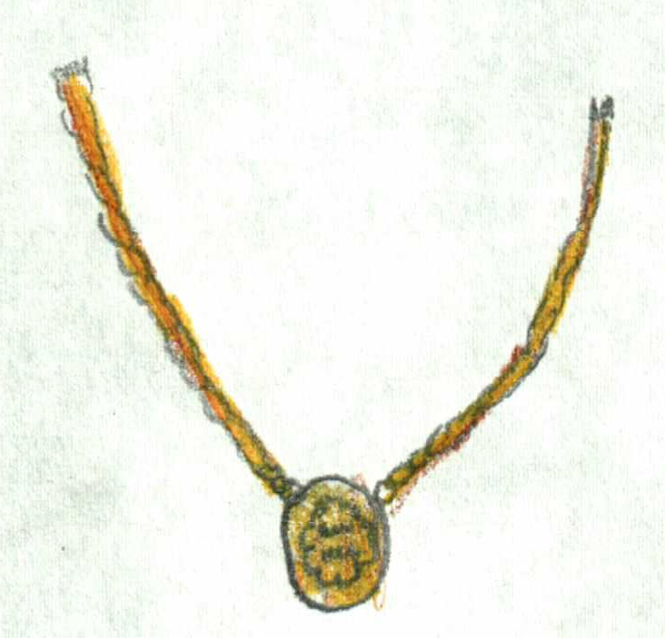
As Susan opened the barn doors she heard the loud creaking of the door and squeaking of the hinges. After Susan had shut the door she slowly walked over to her mother. Her mother Sarah has light green shimmering eyes, long brown dry hair, and she always wore a golden necklace around her neck.

“Good morrow,” said Susan softly.

Her mother sat up startled and gave Susan a surprised smile followed with a warm hug.

“Good morrow to you as well,” she said sweetly.

“Could you please go and grab some eggs for breakfast,” she whispered softly.

“Of course I will momma,” Susan said quietly.

With that Susan strolled over to the front of the barn took and silver pail off a stool and shoved the barn door open. Once she shut doors she started over to the chicken coop located in the back of the barn.

When Susan arrived at the coop the chickens were all outside picking at the damp ground. Susan unlocked the gate, the loud click startled the chickens and they all stood there looking at her curiously. Susan gave a weary smile then slowly steeped farther into the coop. The pen itself is small with dandelions and shrubs growing up from the ground. The coop is light shade blue with a white roof.

After the chickens had a hard enough look at Susan they went back to pecking at the ground hopelessly looking for food.
Susan took a deep breath of fresh air and stepped into the coop. The smell inside the coop was wretched. It was the last place on earth Susan Boardman wanted to be. Trying to ignore the stench Susan slowly walked over to the first nest. It was a little nest made of straw and hay. Susan slowly put her hand into the nest and took out the contents; three soft round eggs and a few pieces of hay. Susan turned on her heels and walked over to another row of neatly filed nest.

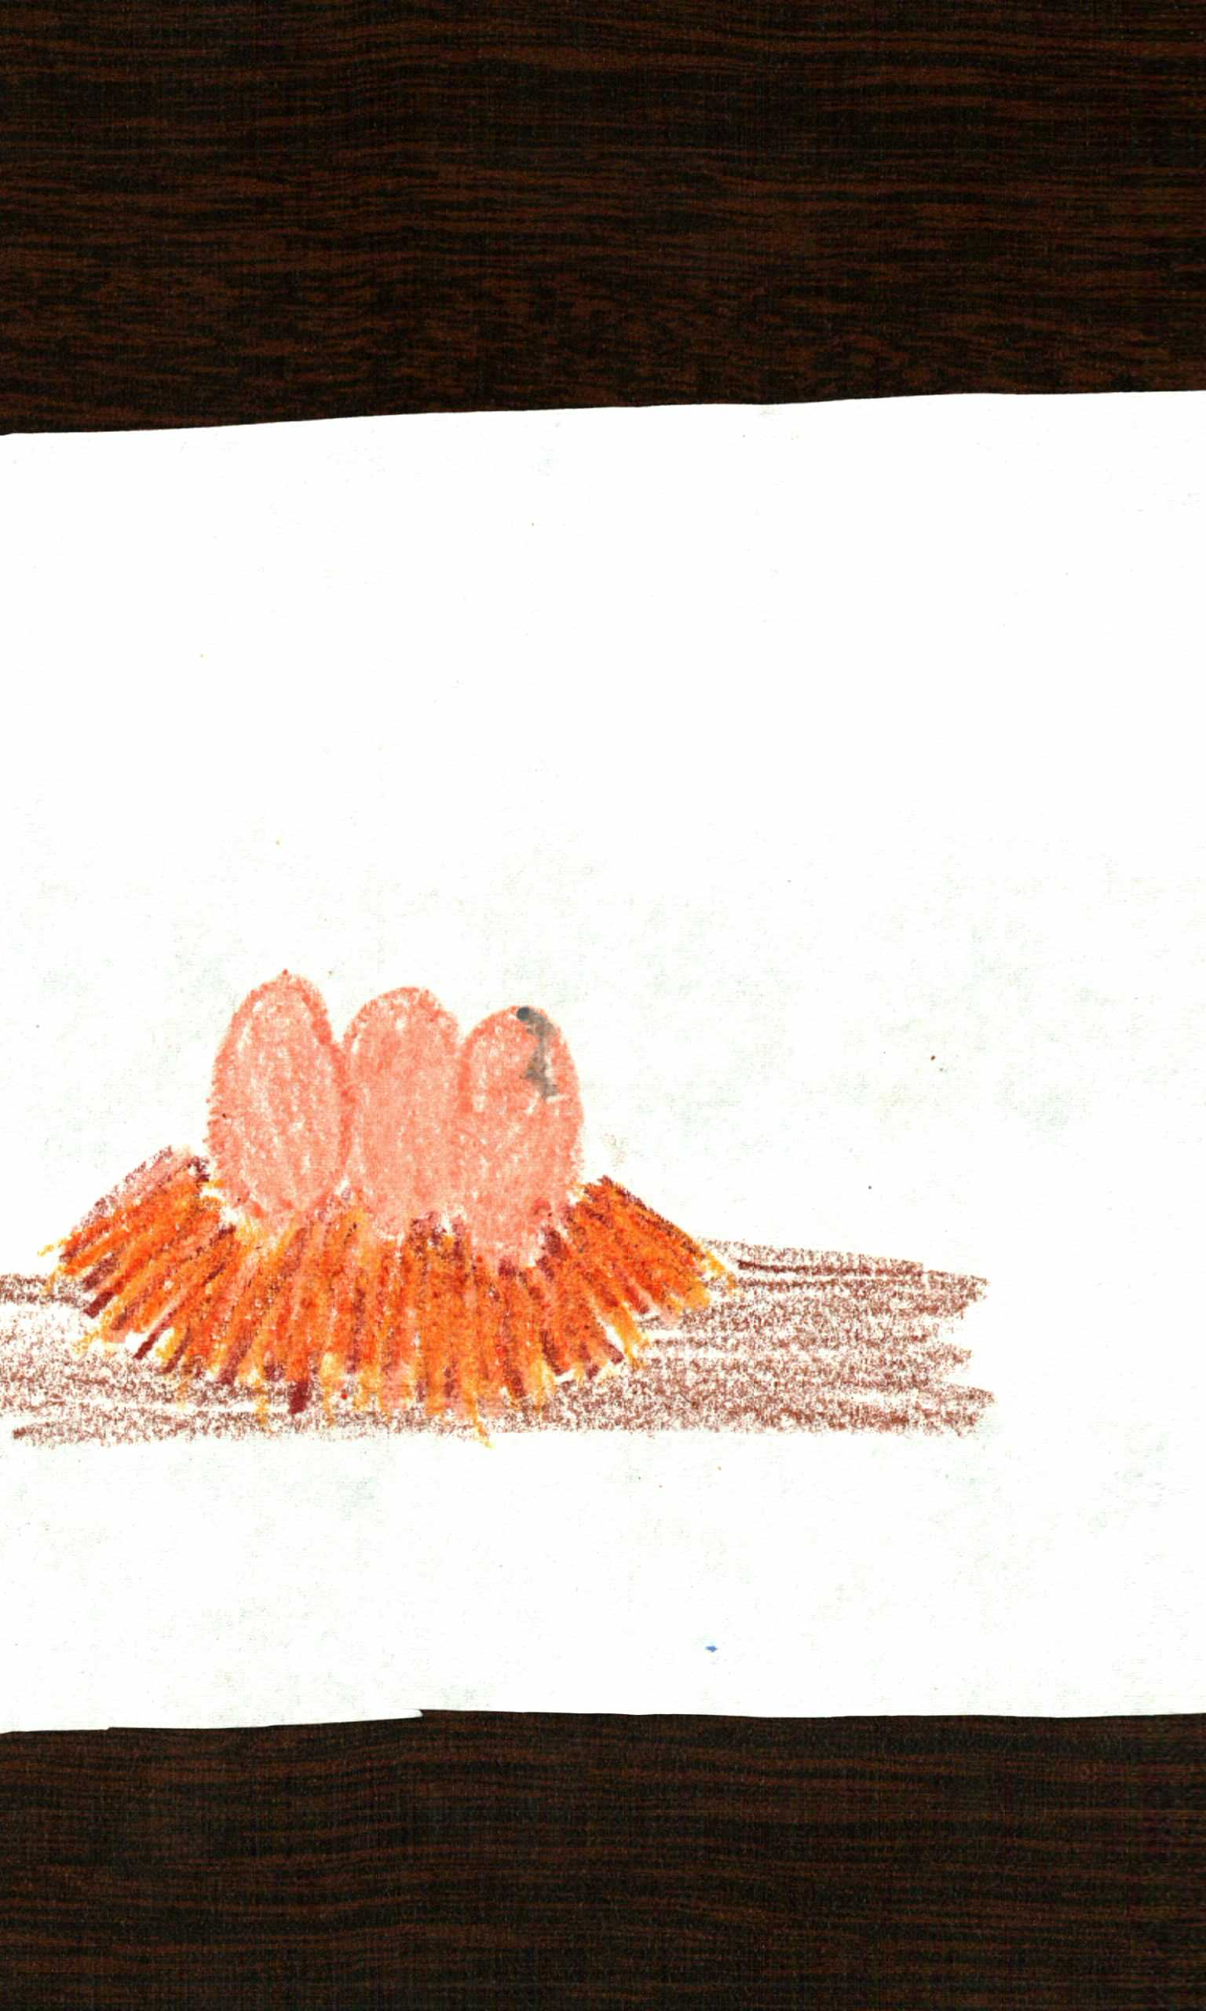

When Susan arrived to the nest she heard an odd scratching sound. She turned and wanted to scream for help but no words could come out. Four hens stood there petrified at the sight of Susan stealing their eggs. As quickly as she could she grabbed three eggs and then ran.

The next few minutes were full of feathers and dirt. When the chickens finally got bored of chewing and nipping, Susan finally made it over to the gate. She fumbled with the lock for a while then swung it open and ran back to the barn. She opened the doors and she noticed her reflection in a shattered piece of glass. Her olive colored skin was now had dirt scattered under her eyes and she had several scratches.

She also had feathers and dirt covering her braid. Her blue gown was filthy as well. When she entered the barn her mother was on the same stool milking a cow. When Susan reached them she stretched her arm out to touch her mother who was hard at work but a loud bang interrupted her.

Susan’s brother Benjamin jumped down from the hay loft covered from head to toes in hay. When he got close enough to realize what his sister was covered in he started to laugh his head off. When his laughing fit had finally stopped he stood up and walked over to his sister and mother. Who he knew were about to give him a big scolding.

“Is that how we greet a person after they get tortured by the chickens? “His mother said angrily.

“No momma,” He said quietly.

With that he walked over to his sister hugged her and whispered sorry in her ear. Susan’s brother is 17 he has the same gray eyes as her farther and light olive skin like Susan. He has blonde wavy hair and light eyebrows. Without saying another word he simply walked over to the horse stalls and opened the door. The huge red chestnut skidded over to him anxious to get out.

“Susan will you hold him a minute,” her brother said while he silently slipped the halter on him.

Susan hesitated she was never allowed to touch the horses for her mother feared she would get hurt but as soon as Susan’s words came back to her throat she said yes.

She slowly walked over to the chestnut and attached her self to the rope. The horse’s big black eyes stared her into the face and she patted his muzzle. She watched as her brother pulled three other horses out of their stalls.

“Follow me,” her brother said softly.

“Aye,” Susan replied.

She tugged on the rope and felt the giant horse lurch forward. As she followed after her brother .She watched the horse very carefully, big round eyes, a chestnut colored coat, a white muzzle, and a tough and strong body with black slick hooves.
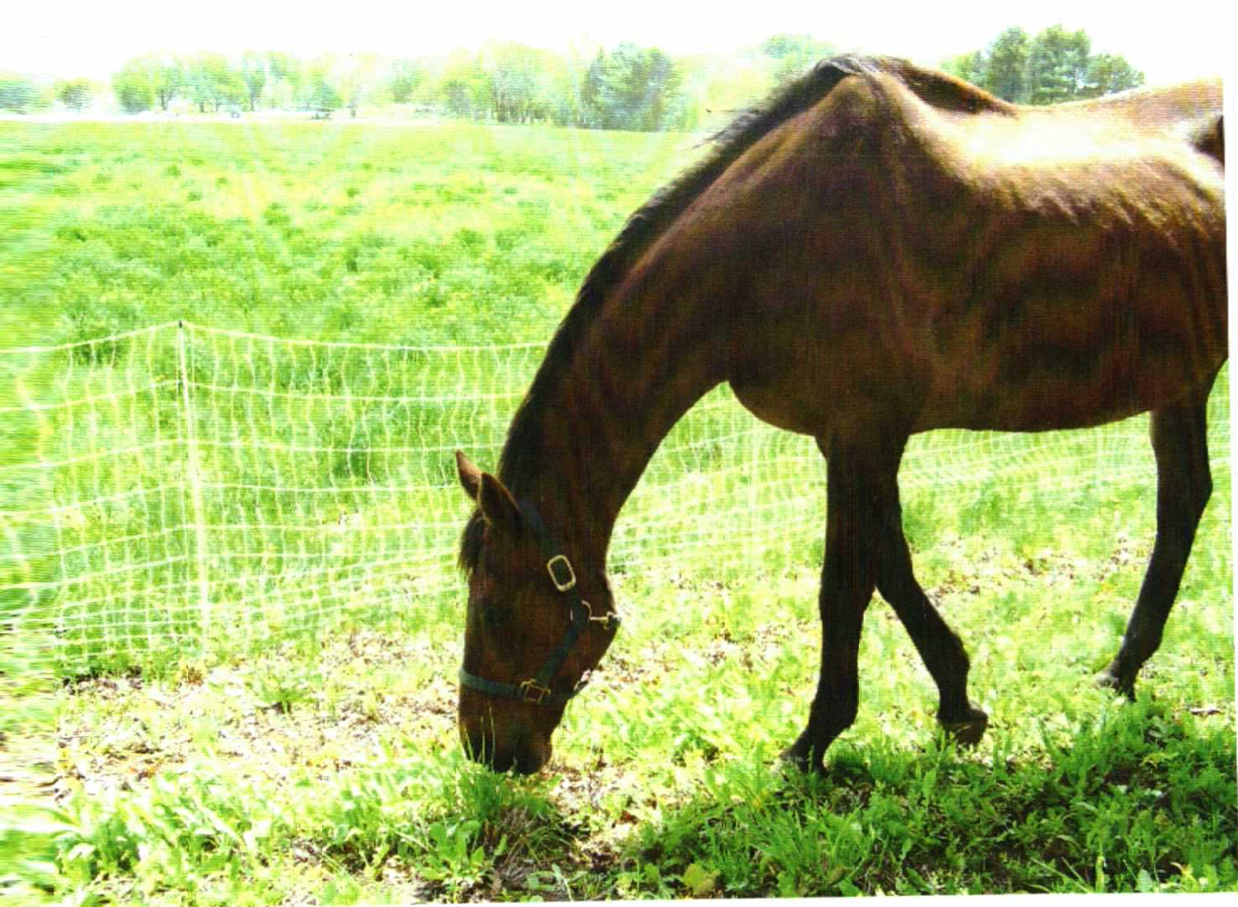

As she walked feathers and dirt picked away from her body and for a second she felt slightly cleaner. When she finally manages to pull the horse that they named Ginger out of a patch of grass she towards her brother who was at the least seventy feet in front of her.

The horse locked his glance on her and then kept walking. Her brother stopped at the gate and stood there staring into the distance like there was something wrong. Susan knew that her brother might be in trouble for letting her lead a horse but she didn’t dare to think about that now.

When she finally reached her brother who was standing by the gate she handed the rope to him and watched the other horses as they waited for there halters to be removed.

“Thanks,” Benjamin said sweetly.

Then he unlatched the gate and led the four horses into the paddock. The paddock is small with green damp grass and a couple thick puddles of water. It’s surrounded with a white gate and a few oak trees.

Once the horses were let free they galloped as fast as they could away from each other. Thrilled to be in the safety of their wonderful field Susan watched for a minute curiously at how they ignored her standing there watching them then she returned to the real world and headed for the barn.

When Susan entered the barn the old burnt hay and oats smell filed her nose and she shook her head to get some of it out. Her mother had left the barn and one the farm helpers - Rachel, - was standing by a hay bale with Susan’s sister Hannah beside her.
“Where have you been,” she said scornfully.

“Sorry my momma-”

Rachel cut Susan off and retaliated by saying;

“Oh if you were with Mrs. Boardman than I suppose that is all right,” she said fatly.

Rachel walked over to her and pulled out four white feathers from her braid and a piece of grain from her dress. Susan was surprised at Rachel’s reaction to her disappearance. As Rachel started picking at her braid Susan yanked it away and swiftly walked towards her sister. Hannah, who was only five years old she had dark chocolate eyes and blonde hair. She was holding her old doll that she named Ms. Buttercup. Her sister had the doll tightly grasped against her chest and it seemed she wouldn’t let it go.

Susan turned towards the door and walked quickly to it before Rachael could instruct her to another chore. Rachel couldn’t even say a word being that Susan swung the doors open and ran towards their house. She heard the shout to come back but she ignored it and kept running. When she reached the house she noticed that the door was open and smoke was drifting out. Offin was home.

She was nearly in the house when she saw the man with wide shoulders, misty gray eyes, light brown hair and a soft light blue coat. He was sitting at the table reading the paper while small puffs of smoke seeped out the brown pipe that was clasped between his pale lips. He looked up to see her walking over to him.

Susan `s papa was 40 and loved to go sailing. He was just in England and had been there for three weeks. He had never had been gone that long but Susan’s guess was he had some kind of work to do there.

Susan didn’t bother to comment instead she just ran to him and let his huge arms trap her close to his body in a warm hug. She smelt the smoke in his heavy thick breathes.

When he finally let go Susan had realized that she had left a few feathers on his shoulders and a couple specks of dirt. She quickly rubbed them off and stood in front of him.

“I missed you papa,” Susan said nicely.
“I missed you as well,” he said sweetly.

With that Susan ran up the stairs and into her chamber. Right before her eyes were a few soft blankets covering a small little wooden bed that Susan got last year for her fifteenth birthday. Her sister who was only five still had a huge heap of warm soft blankets and a pillow. Susan’s bed was next to a window and sister’s was across the room. Susan strolled over to the window and watched as her farther was walking over to the barn and her mother was in garden watering there flowers.

Without paying the least bit attention she walked over to a shelf and grabbed a woolen dress from it. She undressed and slipped on the other dress. She undid her braid and walked slowly out of the room. She allowed herself down the stairs and into the kitchen where she walked towards a pot full of cold water. She dipped her hair into the coldness and let the feathers float off.

Once she finished with her hair she went back outside and over to the garden as fast as could. Her mother was in a patch of roses when she arrived and sat up at the sound of her footsteps.

“Momma,” Susan said quietly.

“Aye,” she said back.

“Why, is there anything I can assist you with,” she replied.

“Nay not right now but I will find you later if there is anything I come across,” Her mother said with a smile then returned to work.

Susan lit up with joy she had a little time to herself to do anything she wanted to. She fumbled over what to do then decide to head for the paddock to watch the horses. When she arrived one of the horses was at the gate by the oak tree so she decided to walk over that way. When the horse noticed her arrival he proudly galloped over to greet her. The black was huge just like the chestnut. He had the same strong body and tough strong hooves. He had one light blue eye and one that was dark brown.

After the horse had left Susan quickly realized she still had time left so she carefully walked over to the tree. It was big with long thick branches. It had green leaves and sap covered some of fine branches. Susan thought about for a minute and then let escape her mind. No.

I can’t climb that tree I will be in huge trouble plus I might get hurt

After thinking for a while she sat down at the base of the tree where she found an acorn she threw it and it landed in the paddock. She ignored the yells of her brother from the corn field and consecrated on a worm that was trying to wiggle its way through the dirt. She sat up and walked towards the gate. The horses were back in the barn and the long stretch of green grass seemed quite for a minute. When Susan heard her mother’s voice she turned and walked towards the barn. When she reached it she realized her mother was in the house so she ran over to the house. Her mother was on the porch with a wooden bowl in her hand. It had steam coming out and it was a creamy white.

Susan followed her mother in to the kitchen. It was a small little room with a wooden table in the middle and a huge stone fireplace. It had a bowl full of cold water to wash your hands and a cupboard full of dishes and silver wear. She silently picked dishes and started over to the cold water when her mother told her elsewhere.

“I was wondering if you could go and fetch more cold water from the well,” her mother said without hesitation.

“Aye momma I shall go right away,” Susan said proudly.

Susan walked towards the cupboard to get the pail and grab her one pair of boots. Near the well it’s colder than usual and it’s wet and damp. The water seeps through the grass everywhere you step and the pigs live just across the road.

Susan was surprised that she was chosen to get the water she had never really done it before but had taken the trip with her mother sometimes to see what it’s like. When Susan stepped on out onto the porch Hannah was sitting on one of the steps with her doll. Susan carefully stepped around her and down the steps to the ground.

“Where you off to,” she said curiously.

“Why I am off to the well if you want to come,”? Susan said.

“I will come I guess,” she said flatly.

Susan grabbed her sister’s hand and they both started off words the well.

Meanwhile Mr. Boardman walked down the brick path and over to the barn he opened the doors and walked over to the horses. He knew that Benjamin was in the fields so he decided to take the horses back out into the paddock for the evening. All four horses quickly agreed into their halters and all walked slowly along with Mr. Boardman. After the horses were let free in the paddock Mr. Boardman walked back to the barn slowly.

“Hannah will you start pulling the lever,” Said Susan.

“Aye Susan,” Hannah said quickly.
As soon as the rope came up Susan tied on the bucket and Hannah sent it back down for some water. When the bucket returned it was full of cold water and the handle was very slippery. After hauling the water back to there house they slipped out of the boots and walked into the kitchen where their mother was making supper for their family. After handing her the water the two girls headed to the parlor where they found there farther sipping tea from a cup and chatting with a man they had never seen before. They watched from behind the threshold as the two men chuckled and talked finally Hannah took interest and walked into the room with a glowing face. Susan stood up and followed her sister into the room.

“Papa, momma just started supper and it will be ready soon,” She said not even paying attention to the other man.

“Oh why thank you dear now your mother might need help,” he said slightly annoyed at the interruption.

Hannah, like a cat cuddled up on her father’s lap and pretended not to be listening. Instead of “listening” she played with her doll and ignored the two men talking.

When Susan entered the kitchen her momma was at the fire place with two carrot sticks in one hand and a wooden spoon in the other. She turned around to her daughter walking in and asked her to stir the soup. Doing as her mother told, she walked towards her mother took the spoon from her hand nicely and stuck it into the soup. Susan felt the soft steam curl up on to her face sink into her skin making her warm inside. She quickly stirred the soup and then handed the spoon to her mother.

“Honey would you mind going and fetching your brother in the field for me,” she asked almost afraid at the answer?

“Of Course momma but I won’t be back in time the field is a real far walk from here,” she said sounding confused.

“You could ask you’re farther to saddle up a horse for you,” she said sounding desperate.

“Alright I will try not to tarry and go quickly,” she said sounding proud.

When Susan farther hoisted her on to ginger she though she might fall off. She held the reins and with that ginger briskly trotted off towards the field. She turned and watched there house grow smaller. The breeze made her braid fly behind her and when she finally made it to her brother he was half way to the river witch was a mile from there house.

She pulled the reins and ginger walked slowly to her brother. Benjamin turned right in time to see her younger sister walking towards her on her mount.

“Dinner is ready Ben momma wants you back to the house now,” Susan said.

“Aye Susan I will be in in a minute,” he said and picked his tools up and followed Susan and ginger back to the barn.

When Susan past the paddock the horse trotted over to greet them but the gate stopped them and they just whinnied instead. When the reached the barn Susan slid of ginger and patted her softly on the nose. Still a little stiff from sitting saddle back on ginger she started back off to the house to eat super.

When she entered the house the smell of warm chicken broth filled her mouth and she heard her stomach grumble. She walked into the dinning room and sat down the weird man was there and at the moment Rachel was serving him tea.

He locked at Rachel and smiled she smiled back and then stared at the table to see all there nice silver wear was on the table and seven gold goblets were being carried in by her mother.
“Oh dinner looks wonderful” said the man from the other side of the table

“Oh why thank you Mr. Walker,” Her mother said back.

Susan’s mother got up and walked towards her. She leaned down and whispered in her ear go put on a clean dress. Susan nodded and fled from the room. When she reached her chamber her sister was in there with Rachel trying to pull a puffy white gown over her head. Susan put her on dress, did her hair and had Rachel place a silver necklace around her neck. She put on a pair of silver flats and went back down to the parlor.

Her mother was pleased to see that she was now dressed and told her to sit down. When Rachel and Hannah joined them momma asked Rachel to go fetch Benjamin.

As Rachel left the room she heard a whinny and noticed that Benjamin was walking Ginger back to the paddock. She ran to catch up to him but he was in the paddock when she arrived.

“Suppers ready,” she called.

“Alright, I am coming,” he sounding disappointed at this.

Once he made it out of the paddock he dried his hands on his knees and walked back to the barn with Rachel.

PREVIOUSLY...

Mr. Boardman took Ginger’s halter and put on her. Then he turned to see a squirrel eating the horse feed. He yelled and his pipe fell to the ground and caught a strand of hay.

BACK TO THE FUTURE

When Rachel and Benjamin got back to the Boardman house, Benjamin remembered he had the halter. He turned and started off to the barn but Rachel chased after him and took the halter from his hands.

“You need to go back to the house there expecting you for dinner,” Rachel said.

“Aye,” Benjamin said quietly and walked back to the house.

When Benjamin entered the house his mother gave him a glare which he knew wasn’t good. He quickly ran up to his chamber, changed and came back down for dinner.

After everyone had sat down for dinner Momma called for Rachel.

“I will go grab her momma,” said Susan.

“Alright do not tarry,” she said quite annoyed.

Susan picked up her skirt and walked out of the room. She turned the corner and walked out on to the porch. She again picked up her skirt and paced down the wooden steps.

“Ahhhhhh,”

“MOMMA PAPA COME QUICK,” Susan screamed from the porch.

The barn was on fire …

Her mother, father and Mr. Walker ran to the porch to see their beloved barn burn to flames.

10 MINTUES LATER

About three horse drawn fire engines came screeching down the street. Mrs. Boardman made Susan and Hannah go to bed but Benjamin got to stay up and help the firemen.

(Susan’s Point Of View)
The next morning brought sad news. Rachel had died in the fire and today was her funeral. I walked up the stone stairs and into my chamber. I slipped on my black laced funeral dress and new black boots. I did my hair in a bun and walked down the stairs.
The funeral was today, tears cascaded down my cheeks at the thought of Rachel dying I couldn’t bear it. I cried till my eyes hurt. Nothing, not one piece of her body was found, anything she had burned to pieces. I had to speak and I was not prepared but I didn’t have a choice. I walked up to the podium where her casket laid open.

I pulled my self together.
“Good Morrow, I am Susan Boardman I lived with Rachel for a very long time and I am still adjusting to her lost. I knew Rachel like nobody else. She taught me how to knit and how to milk a cow also how I was supposed to dress when we had company. Rachel was more than just and helper she was a friend and I am so upset she had to leave so early. Rachel died because she was trying to help my brother he would have been in the casket if it weren’t for her and even though I am a mess because of her death I am grateful it’s not my brother’s funeral. Rachel was my diary and now that my diary is dead I have no more secrets to keep. I loved Rachel like family and I can’t say how much I will miss her. I love you Rachel, Amen.”

Susan crumbled the piece of paper in her hand and dragged her self to her seat while the building erupted with clapping after her speech.

THE END

Dedication

I dedicate this book to my mom and dad who taught me to never give up and to shoot for my dreams, also to my grandparents who have taught me determination.

About the Author


Bella is 11 years old and lives in Newburyport, Massachusetts with her mother, Giulia and father, Joe. She has two younger siblings Ryan her 9 year old brother who and Victoria her 7 year old sister. Bella enjoys horseback riding, swimming, gymnastics, soccer, skiing. She has three cats named Simon, Marley and Kitty she also has a bunny named Benny. She has also written a book on the zebra. Bella also loves hanging with her friends and going to the beach.

